Data Handling and Visualization (DSA06)
Name: Prasanna M Reg. No: 1925260244
Set 21: Energy Consumption Analysis
Question 1. Import the dataset in R. Plot a histogram and density plot for Units_Consumed. Compare consumption patterns.
Program (R):
energy <- read.csv("Energy_Consumption_Data.csv")
library(ggplot2)
ggplot(energy, aes(x = Units_Consumed)) +
geom_histogram(aes(y = after_stat(density)), breaks = seq(300, 1050, 150),
fill = "steelblue", colour = "black", alpha = 0.8) +
geom_density(colour = "red", linewidth = 1) +
labs(title = "Histogram and Density of Units Consumed",
x = "Units Consumed (kWh)", y = "Density") +
theme_minimal()
Output:
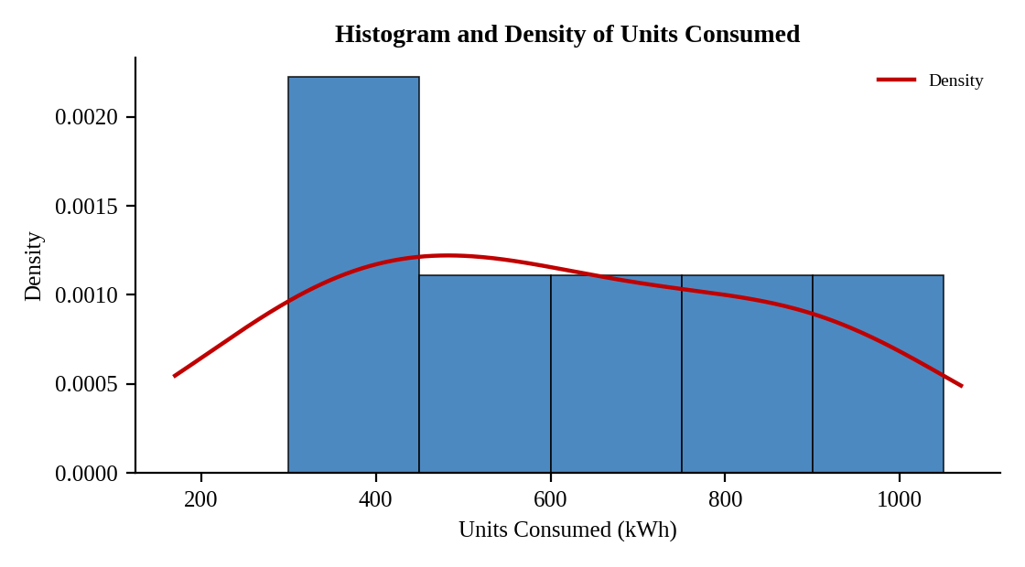
Interpretation:
Consumption falls into three groups: Residential (320 to 350 kWh), Commercial (540 to 610 kWh) and Industrial (880 to 920 kWh). The density curve is therefore spread out with several humps instead of one peak.
The mean is 603.3 kWh and the median is 575 kWh. Industrial users consume almost three times as much as residential users.

Question 2. Using R programming, create a scatter plot between Temperature and Units_Consumed. Represent Peak_Hours using bubble size. Apply transparency.
Program (R):
ggplot(energy, aes(x = Temperature, y = Units_Consumed, size = Peak_Hours)) +
geom_point(alpha = 0.5, colour = "steelblue") +
scale_size(range = c(3, 12)) +
labs(title = "Temperature vs Units Consumed",
x = "Temperature (°C)", y = "Units Consumed (kWh)", size = "Peak Hours") +
theme_minimal()
Output:
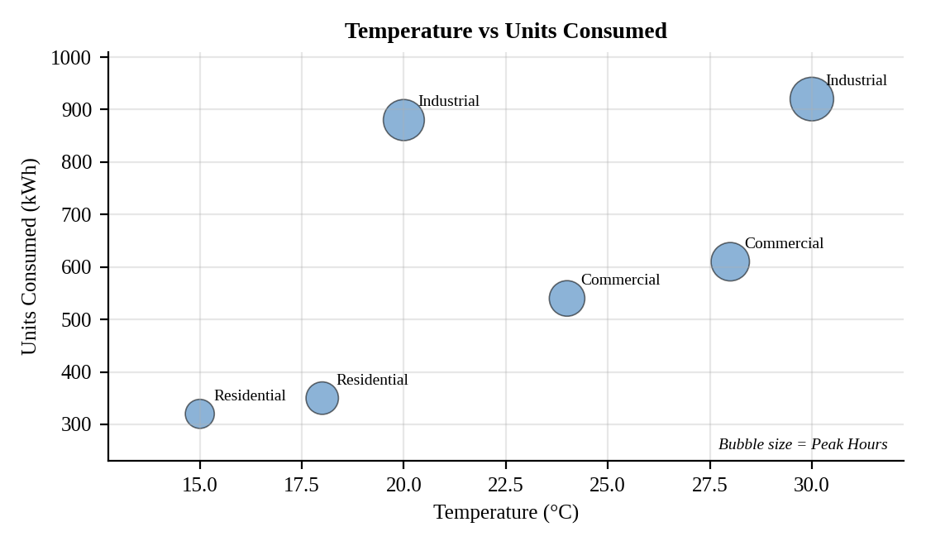
Interpretation:
There is a moderate positive link between temperature and consumption (r = 0.65): warmer readings are generally accompanied by higher use. The relation between peak hours and consumption is much stronger (r = 0.98); the largest bubbles are the highest-consumption points. Sector, not temperature, is the main driver of consumption.

Question 3. Using R, calculate average Renewable_Usage for each Sector. Create a bar chart. Interpret renewable energy adoption.
Program (R):
avg_ren <- aggregate(Renewable_Usage ~ Sector, data = energy, FUN = mean)
print(avg_ren)
ggplot(avg_ren, aes(x = reorder(Sector, -Renewable_Usage), y = Renewable_Usage, fill = Sector)) +
geom_col(colour = "black", width = 0.6) +
geom_text(aes(label = paste0(round(Renewable_Usage, 1), "%")), vjust = -0.3) +
labs(title = "Average Renewable Usage by Sector", x = "Sector",
y = "Average Renewable Usage (%)") +
theme_minimal() + theme(legend.position = "none")
Output:
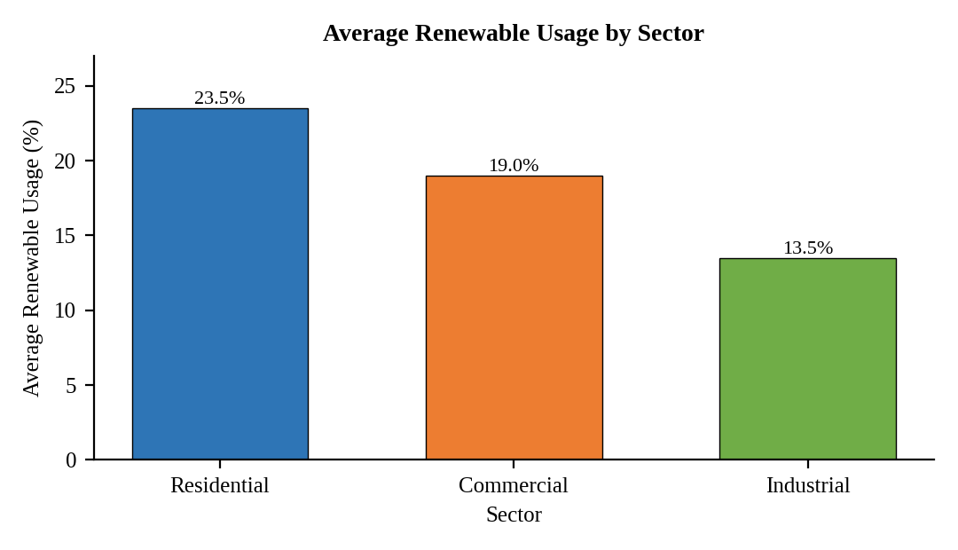
Interpretation:
Average renewable usage is 23.5% for Residential, 19.0% for Commercial and 13.5% for Industrial. Adoption falls as consumption rises: the biggest consumers use the least renewable energy, so the industrial sector has the most room to improve.

Question 4. Import Energy_Consumption_Data.csv into Tableau. Create a line chart for monthly energy usage trends. Create a heatmap (Sector vs Region vs Units). Add filters for Month and Sector. Design an interactive dashboard.
Procedure (Tableau):
1. Open Tableau, click Connect, choose Text file / Microsoft Excel, select "Energy_Consumption_Data.csv" and open Sheet 1.
2. Sheet 1 (Line): Columns = Month (discrete, order Jan, Feb, Mar); Rows = SUM(Units_Consumed); mark type = Line with circles; add labels.
3. Sheet 2 (Heatmap): Columns = Region; Rows = Sector; drag SUM(Units_Consumed) to Color and Label; mark type = Square; choose a sequential colour palette.
4. Right-click Month and Sector in the Dimensions pane, choose Show Filter, and apply both filters to all sheets (Apply to Worksheets > All Using This Data Source).
5. Click New Dashboard, name it "Energy Dashboard", set Size to Automatic and drag the sheets onto the canvas.
6. Select each chart and click the "Use as Filter" icon so that clicking a mark filters the other sheets; keep tooltips enabled.
7. Add a title to every sheet, adjust labels and colours, and save the workbook (File > Save As, .twbx).

Output:
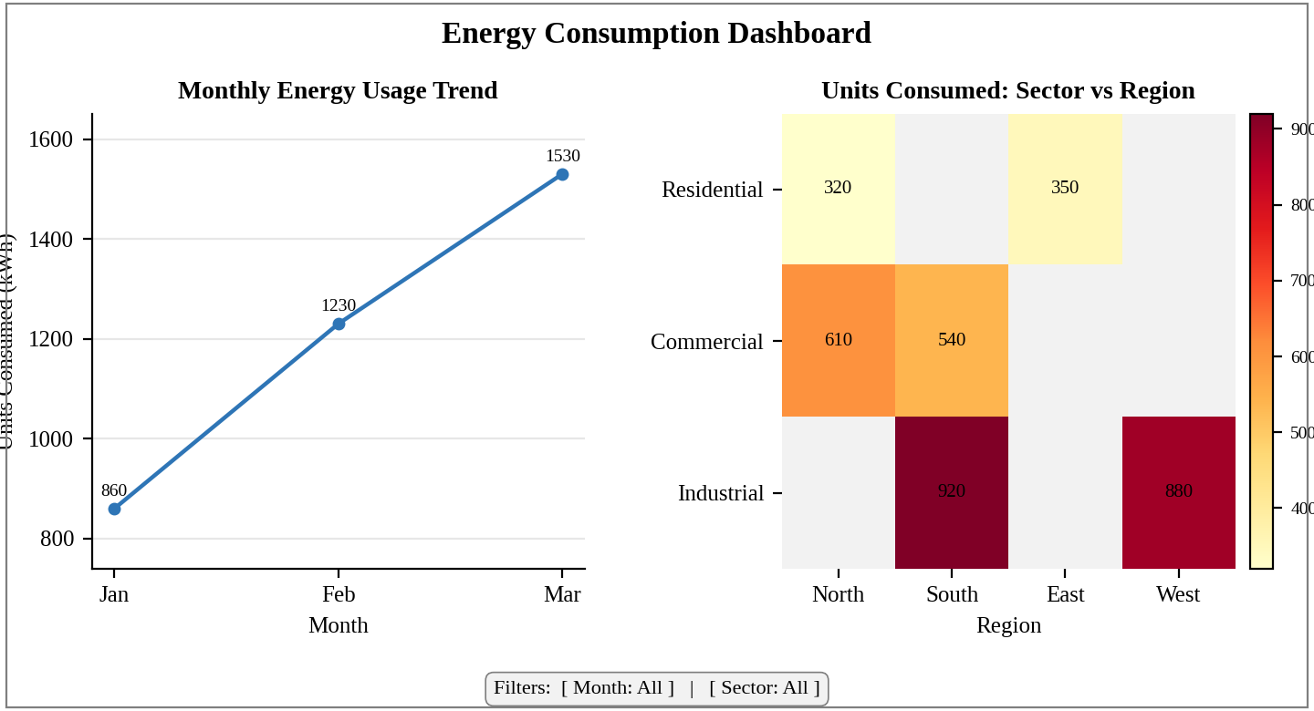
Dashboard layout (preview of the Tableau output).
Interpretation:
Total consumption rises every month, from 860 kWh in January to 1230 kWh in February and 1530 kWh in March. The heatmap shows the darkest cells for the Industrial sector (West 880 kWh, South 920 kWh), so industrial demand drives the growth. The Month and Sector filters let a user isolate any combination.

